Student ID: s8117545

Student Name: Ankit Shrestha

Lab Activity: Lab 1.1

Problem:

Write a program that converts hours to its equivalent in minutes first then to seconds and prints the results on the screen. The program should request a number representing the hours and converts it into minutes then seconds. Make sure to use the following constants in your program, for example MINUTES_PER_HOUR = 60; SECONDS _PER_ MINUTE = 60.

Code:

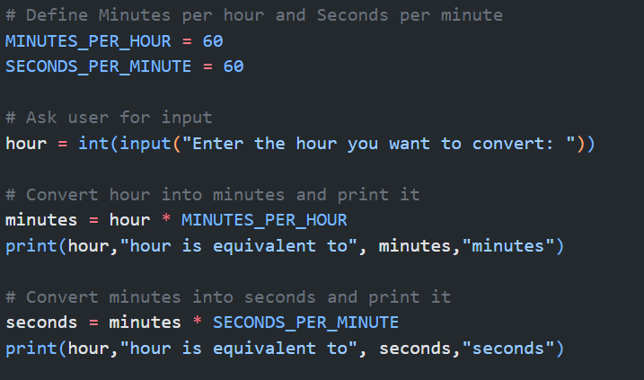

Test Run 1:

Test Run 2:

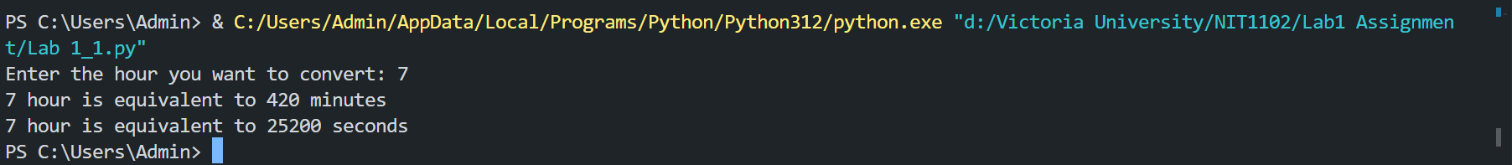

My Peer:

Student Name: Sam Greco  
Student ID: s8099162

Feedback Received:

Works Perfectly

Feedback Given:

The code is working perfectly